**Global Food Production Trends and Analysis: A Comprehensive Study from 1961 to 2023 Using Power BI**

Dashboard:

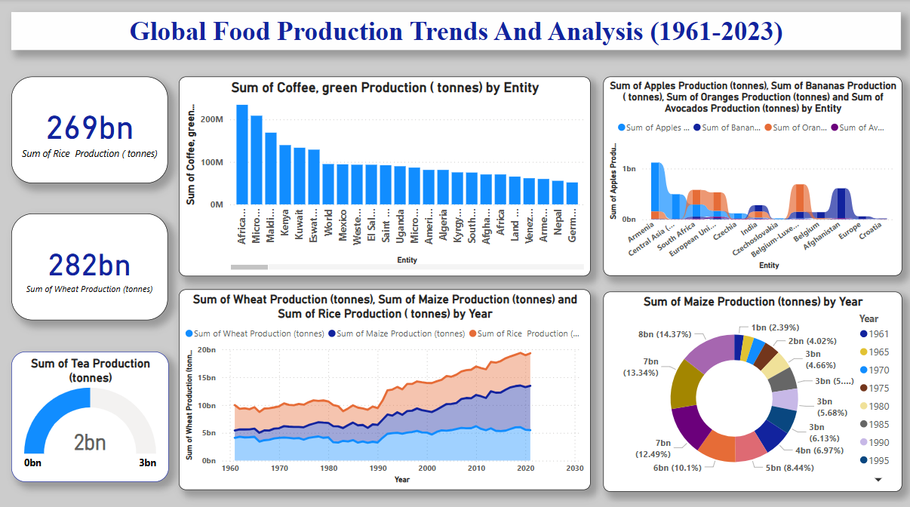

Report:

